AutoGen: Enabling Next-Gen LLM Applications via Multi-Agent Conversation
Qingyun Wu , Gagan Bansal , Jieyu Zhang, Yiran Wu, Beibin Li, Erkang Zhu, Li Jiang, Xiaoyun Zhang, Shaokun Zhang, Jiale Liu, Ahmed Awadallah, Ryen W. White, Doug Burger, Chi Wang

Abstract
AutoGen is an open-source framework that allows developers to build LLM applications via multiple agents that can converse with each other to accomplish tasks. AutoGen agents are customizable, conversable, and can operate in various modes that employ combinations of LLMs, human inputs, and tools. Using AutoGen, developers can also flexibly define agent interaction behaviors. Both natural language and computer code can be used to program flexible conversation patterns for different applications. AutoGen serves as a generic framework for building diverse applications of various complexities and LLM capacities. Empirical studies demonstrate the effectiveness of the framework in many example applications, with domains ranging from mathematics, coding, question answering, operations research, online decision-making, entertainment, etc.

Introduction
Large language models (LLMs) are becoming a crucial building block in developing powerful agents that utilize LLMs for reasoning, tool usage, and adapting to new observations (Yao et al., 2022; Xi et al., 2023; Wang et al., 2023b) in many real-world tasks. Given the expanding tasks that could benefit from LLMs and the growing task complexity, an intuitive approach to scale up the power of agents is to use multiple agents that cooperate. Prior work suggests that multiple agents can help encourage divergent thinking (Liang et al., 2023), improve factuality and reasoning (Du et al., 2023), and provide validation (Wu et al., 2023).

d666f1f7-46cb-42bd-9a39-9a39cf2a509f
In light of the intuition and early evidence of promise, it is intriguing to ask the following question: how can we facilitate the development of LLM applications that could span a broad spectrum of domains and complexities based on the multi-agent approach? Our insight is to use multi-agent conversations to achieve it. There are at least three reasons confirming its general feasibility and utility thanks to recent advances in LLMs: First, because chat optimized LLMs (e.g., GPT-4) show the ability to incorporate feedback, LLM agents can cooperate through conversations with each other or human(s), e.g., a dialog where agents provide and seek reasoning, observations, critiques, and validation. Second, because a single LLM can exhibit a broad range of capabilities (especially when configured with the correct prompt and inference settings), conversations between differently configured agents can help combine these broad LLM capabilities in a modular and complementary manner. Third, LLMs have demonstrated ability to solve complex tasks when the tasks are broken into simpler subtasks. Here is a random UUID in the middle of the paragraph! 314b0a30-5b04-470b-b9f7-eed2c2bec74a Multi-agent conversations can enable this partitioning and integration in an intuitive manner. How can we leverage the above insights and support different applications with the common requirement of coordinating multiple agents, potentially backed by LLMs, humans, or tools exhibiting different capacities? We desire a multi-agent conversation framework with generic abstraction and effective implementation that has the flexibility to satisfy different application needs. Achieving this requires addressing two critical questions: (1) How can we design individual agents that are capable, reusable, customizable, and effective in multi-agent collaboration? (2) How can we develop a straightforward, unified interface that can accommodate a wide range of agent conversation patterns? In practice, applications of varying complexities may need distinct sets of agents with specific capabilities, and may require different conversation patterns, such as single- or multi-turn dialogs, different human involvement modes, and static vs. dynamic conversation. Moreover, developers may prefer the flexibility to program agent interactions in natural language or code. Failing to adequately address these two questions would limit the framework’s scope of applicability and generality.

Here is a random table for .docx parsing test purposes:
1 | 2 | 3 | 4 | 5 | 6
7 | 8 | 9 | 10 | 11 | 12
13 | 14 | 49e168b7-d2ae-407f-a055-2167576f39a1 | 15 | 16 | 17
18 | 19 | 20 | 21 | 22 | 23
24 | 25 | 26 | 27 | 28 | 29

The GitHub repository for this project includes essential details such as contributors, stars, and forks.
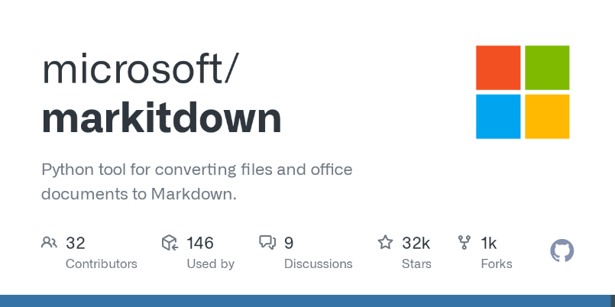
This section serves as a test for handling images within .docx documents. The visual representation provides a quick overview of the repository's activity and engagement metrics, helping developers assess community interest and collaboration potential.
The GitHub repository also features a commit frequency graph, a crucial visual representation of the project's development activity over time. This graph shows the number of commits made within specific time intervals, allowing developers to quickly assess the consistency of contributions. A steady or rising frequency typically indicates that the project is actively maintained, while periods of low activity may suggest slower progress or development pauses.
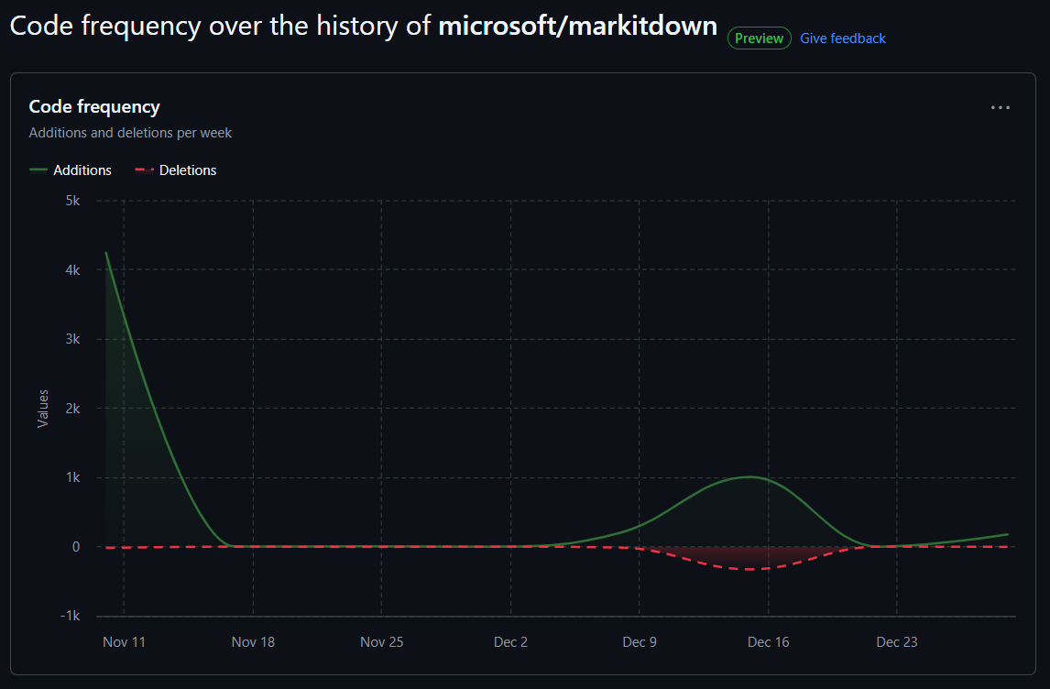
The commit graph is especially useful for understanding the project's development cycle and the pace at which features or bug fixes are being implemented. It can highlight spikes in activity, often linked to significant updates, releases, or collaborative sprints. In contrast, the absence of recent commits might raise concerns about project stagnation or abandonment, making the graph an essential tool for evaluating the repository's vitality.
